System Requirements Specification for
<NAME OF THE SYSTEM>
<NAME OF THE COMPNAY>

Prepared By: <Who created this document>
Date Created: <date started>
Last Update: <Last updated>
Version: <Versions of creation>

Reviewed By:
<Personnel you have interviewed>
<Personnel you have interviewed>
<Personnel you have interviewed>
<Personnel you have interviewed>
<Personnel you have interviewed>

Recommending Approval:

Members
Members
Members
Members
Members

Approved By:

Thom Christian Makiling

Document Control

Change Record
Date | Author | Document Version | Change Reference
 | Member | 2.1 | <Identify all the changes>
 | Member | 2.2
 | Member | 2.3
 | Member | 2.4
 | Member | 2.5

Distribution

Copy No. | Name | Location

Document Control 2
Change Record 2
Distribution 2
1. System history 4
2. System definition 4
3. ObjectiveS 4
4. Scope and SYSTEM CONTROLS 4
5. Intended users 4
6. general Assumptions and policies 4
7. CURRENT Process Flow 5
7.1 <Name of the process flow> 5
8. TO-BE Process Flow 5
8.1 <Name of the Process> 5
9. Narrative of procedures 5
10. <system> Front-end 6
10.1 Login Screen 6
10.2 User Main Screen 7
10.xx System Maintenance: Manage User Accounts 10
11. <SYSTEM> Report GENERATION 12
11.1 <Name of Module/Report> Report 12
13. Non-functional requirements 13
13.1 Environment 13
13.2 Availability 13
13.3 Maintenance 13
13.4 Security and Access Control 14
13.5 Service Continuity 14
14. SYSTEM-GENERATED ID/CODE CONVENTIONS 15
15. TERMINOLOGIES 15

1. System history

System Name:
Version Number: 1.0

Target Date:
Date Started: June 16, 2010

Steering Committee:
- Mr. Sean Oliver G. Meclat

Functional Team Members:
- Members

Technical Team Members:
- Members

2. System definition

3. ObjectiveS

4. Scope and SYSTEM CONTROLS

Scope
- Powered IOX Daily Sales System provides automatic functionality of the manual inputting of sales per product in the company. It focuses on the sales per day of a team in the Powered Iox Company and ensures that all sales are inputted in the database of this system. This system also has the functionality of getting the total sales of an agent and the total sales per day of a specified team.
It has also a multiple viewing of sales per day.

5. Intended users

-Admin and Managers are the target users for this system. For Admin users they will focus on the viewing of data for all managers that are registered in the system.

-Managers are the main target for the encoding of data to the system for viewing its history sales based on the past dates.

Modules | Admin | Manager
Log-In Form | ✓ | ✓
Registration Form | ✓ | ✓
Sales View Form | ✓ | ✓
All Sales Form | ✓
Edit Account Form | ✓

6. general Assumptions and policies

7. CURRENT Process Flow

7.1 <Name of the process flow>

Fig. 7.1 – <Process Flowchart>

8. TO-BE Process Flow

8.1 <Name of the Process>

Fig. 8.1a <Image of the Process flow>

9. Narrative of procedures

10. <system> Front-end

10.1 Login Screen

Primary Function(s):

This screen will serve as the User’s main entry point to the system. The user should fill in the required Username and Password. And will also serve as the register form for the user.

Upon user login, the ff. will be retrieved based on their user accounts:
- As a Team Manager
- Team Manager Sales Database

The entry screen will include the ff.:

For Login:
- Username
- Password

Contributing Function(s):

  - Provide descriptive warning and error messages when exceptions occur.
  - Entering a registered user will have three retries on logging in with an invalid password, If that goes to 0 retries it will give the specified user a penalty.

General Validation(s):

  - Username and password should exist in the database (Team Manager).
  - User must have access rights to the system.
  - User’s access rights should not be expired.

Output:

Allow access to various modules of the system based on the user privileges and/or permission/s granted to the user.

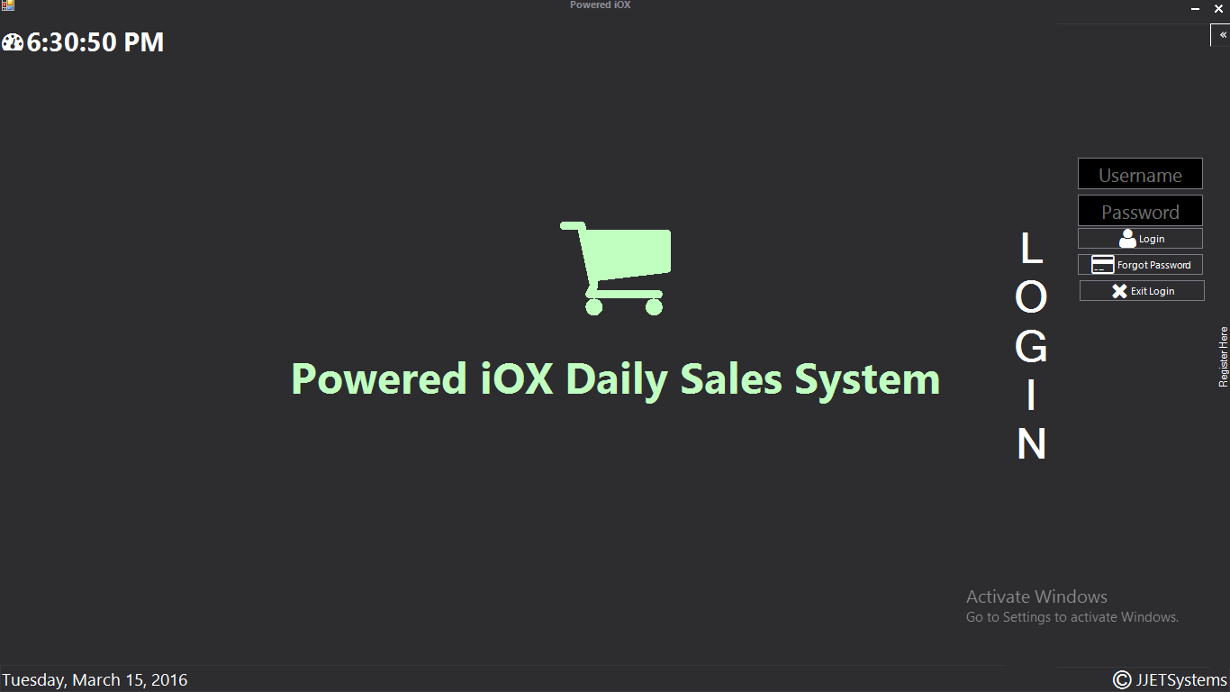
Fig. 10.1 Login Screen

Input Data | Description | Source Type | Validation
User Name | Username based on the existing record in User maintenance | Text Box | - Required value  - Valid username  - User Account  - System User Account and Privileges
Password | Password as defined in user Account | Text Box | - Required value  - Valid username  - User Account  - System User Account and Privileges
Login |  | Button | - Should have selected one account to be able to proceed.  - Disabled by penalty
Forgot Pass |  | Button | - Provides the functionality to recover a forgotten password using the secret question and answer.

Output Data | Description | Output Report
Access to the system | - User’s Access/Privileges | N/A

10.1 Register Screen

Primary Function(s):

This screen will serve as the User’s registration to the system. The user should fill in the required Username, Password, Manager Name, Secret Question and Secret Answer.

Upon user registration, the ff. will be saved based on their inputs:
- As a Team Manager
- Team Manager Sales Database

The entry screen will include the ff.:

For Registration:
- Username
- Password
- Manager Name
- Secret Question
- Secret Answer

Contributing Function(s):

  - Provide descriptive warning and error messages when exceptions occur.
  - Registers the data as manager and shows information that it’s registered on the system.

General Validation(s):

  - Username must not exist in the database (Team Manager).

Output:

Allow registration to access to various modules of the system based on the user privileges and/or permission/s granted to the user.

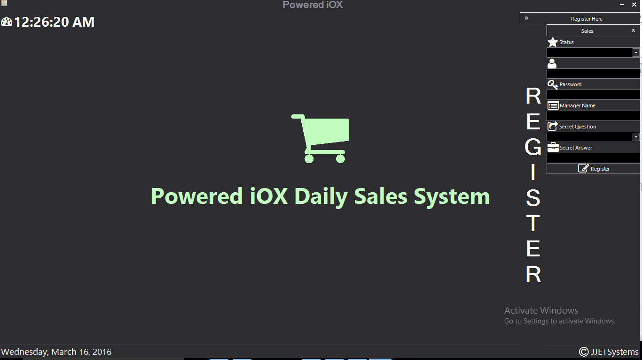

Fig. 10.1 Register Screen

Input Data | Description | Source Type | Validation
User Name | Username that will be used upon logging in | Text Box | - Required value  - Unique username
Password | Password that will be the security code of the account | Text Box | - Required value
Manager Name | The name of the manager | Text Box | - Name of the manager that will use the account
Secret Question | Secret Question Code | Combo Box | - Provides the functionality to recover a forgotten password this will serve as the question to show your password
Secret Answer | Secret Code | Text Box | - Provides the key role to recover your password.

Primary Function(s):

The User Main Screen is the initial screen that will be shown upon login to the System.
It serves as a display, retrieval and monitoring of sales per day.
For each type of Team Manager, the tabular display and records retrieved varies per access and the day selected in the sales calendar.
It also contains an add product and delete product button which is accessible by all types of Team Manager.

The User Main screen will vary depending on the logged-in User Type identified as follows:
- Admin
- Manages the whole system and sales of other managers and edit accounts
- Manager
- Manages his own sales, must register first.

The User Main Menu, which will also vary depending on the logged-in User Type and corresponding access type, are as follows:

Menu | Admin | Manager
Home | ✓ | ✓
Login | ✓ | ✓
Register | ✓ | ✓
Add, Delete, Rename Product | ✓ | ✓
Save and Edit Data | ✓ | ✓
Multiple Sales | ✓ | ✓
View All Data | ✓
Edit  Create Accounts | ✓
Log-off | ✓ | ✓

The User Main Screen Functions and access for modules will vary depending on the logged-in User Type and access:

- User Main Screen/Home Page
- Sales View Screens

MODULES | Admin | Manager
Main Module | ✓ | ✓
Sales Data Module | ✓ | ✓
Accounts Module | ✓ | ✓
Helper Module | ✓ | ✓

The User Main Screen Tab and functionality will vary depending on the logged-in User Type and access:

- User 1
- Admin

User Main Screen Menu | Functions | Request Type
View All Manager Sales | Can select all sales from different managers
Multiple Date Sales | Can view multiple selected dates sales
Edit Accounts | Can edit account information
Log out | Log outs admin

- User 2
- Manager

User Main Screen Menu | Functions | Request Type
Save, Add and Delete Data | Can edit the database
Multiple Date Sales | Can view multiple selected dates sales
Log out | Log outs manager

Contributing Function(s):

  - Display and retrieval of all sales in a data grid showing sales database based on the currently logged in user.
  - Depending on the menu function
  - View Sales
  - Provide descriptive warning messages for all exceptions that may occur.
  - Provide confirmation messages when deleting, canceling and saving.

General Validation(s):

  - Access rights on system modules classified per User Type
  - Menu display identified per User Type
  - User’s access rights per module should not be expired.

Output:

List of sales filtered based on the current user.

Fig. 10.2a User Main Screen
Admin:
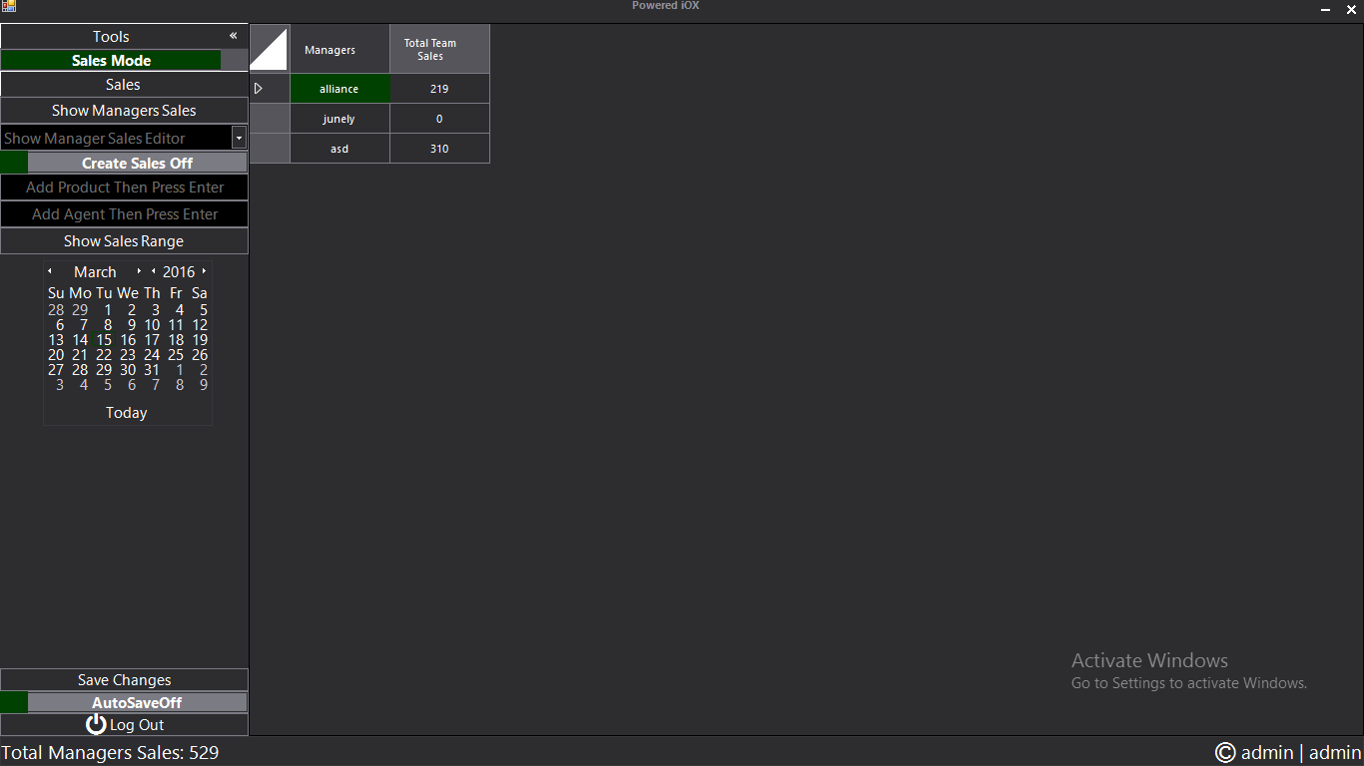

Manager
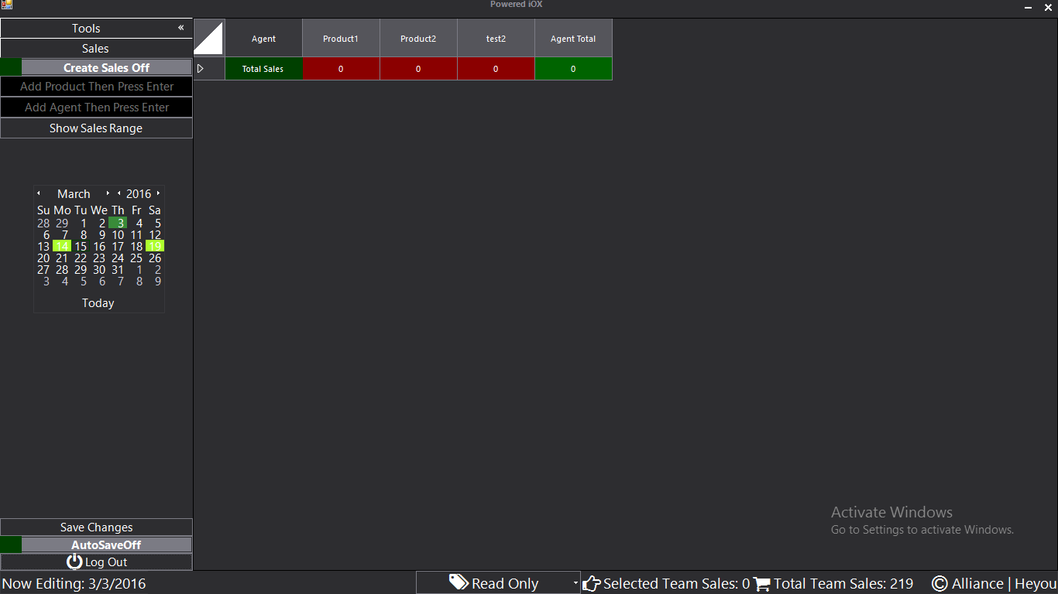

Input Data | Description | Source Type | Validation
Sales View | Sales function as retrieval and displaying of sales given the User Type and Access. | Data Grid | - Must select a date in sales calendar

10.xx System Maintenance: Manage User Accounts

Primary Function(s):

This screen will serve as the maintenance of user account privileges used by the system as reference or look-up for the User Account values and modules access.

Contributing Function(s):

  - Data Grid listing all user accounts with privileges records.
  - Create Account mode for creating new accounts
  - Editing fields for changing the data in the data grid view
  - Provide descriptive warning messages for all exceptions that may occur.
  - Provide confirmation messages when saving.

General Validation(s):

  - Only the system admin account can access this module and will be hidden from all other users.

Output:

User Access and System Privileges as referential look-up for modules access/rights per User Account

Fig. 10.13a System Maintenance – User Privileges Screen <provide a screenshot>

Input Data | Description | Source Type | Validation
User Name | Lists all User Names | <table and database name> | - Required field  - Values derived from User Names from employees record to users Accounts
Create Account Mode | Change it account creation mode | Button
Register | Create the account | Button
User Name | Username | Display/Text
Password | Security Password | Display/Text
Manager Name | Name of the manager | Display/Text
Secret Question | Question for recovering forgotten password | Display/List
Status | Status of the account
Secret Answer | Answer for the secret question | Display/Text

11. <SYSTEM> Report GENERATION

11.1 <Name of Module/Report> Report

Fig. 11.1a <name of module> Report Input Parameter Screen

Input Data | Description | Source Type | Validation

Report Specifications:
- <specify all the reports needed>

13. Non-functional requirements

13.1 Environment

Server Requirements

Hardware Requirements:
- <Identify the hardware needed (harddisk, memory, processor, etc)>

Software Requirements:
- <Identify the software needed (operating system, crystal reports, etc.)>

Speed of network access:

Type of network access:

13.2 Availability

Application availability requirement:

Service availability :

Service Level Commitment :

13.3 Maintenance

Data back-up
- On-site/Offsite back-up

Data/files needed to be back-up
- Database (ORS)

Frequency of back-up
- Full Backup (Every Sunday)
- Differential Backup (Every night)
- Transactional Backup (Every 2 hours)

13.4 Security and Access Control

Position/  Function | User Type | Modules | Access Type
System Administrator | Administrator | Identify the modules | Full  Full  Full  Full  Full  Full  Full  Full  Full  Full  Full  Full
Granting of access
- <Identify on how a user can be given an access>
Changing, canceling of access
- <Identify on how to cancel a user’s access>

13.5 Service Continuity

How long business can operate without the system?
- <Identify>

Estimated lead time to set up system (based on latest back-up)?
- <Identify>

Who will be involved in the recovery procedures (process owners)?
- <Identify>

Where the system can/will operate upon recovery?
- <Identify on how the system will work on the company>

14. SYSTEM-GENERATED ID/CODE CONVENTIONS

CODE | DESCRIPTION | FORMAT | SAMPLE VALUE(S)
EMPNO | Employee number | The first 4 digit is the year and the remaining digit is the auto generated number assigned to an employee | 19973621

15. TERMINOLOGIES

ACRONYMS/TERMS | DESCRIPTION

